**CS201 – Fall 2019-2020 - Sabancı University**

**Homework 1 – International Phone Roaming Costs**

**Due October 2, Wednesday, 22:00**

**Description**

In this homework, you will write a C++ program that performs a basic calculation on the bill of your international phone usage when you are abroad, which is also called roaming. User name, the price of outgoing call per minute, the minutes talked in outgoing calls, the price of incoming call per minute, minutes talked in incoming calls, the price of internet usage per MB, the number of GB’s of internet used, the price of one SMS, and the number of SMS’s sent will be the inputs of the program. Your program will calculate the phone bill for each of the outgoing calls, the incomings calls, the internet usage and the SMS’s. Additionally, your program will also calculate the total cost of all these roaming services with 18% tax imposed and the total roaming bill fee including the tax.

All program flow may be computed in the *main* function. i.e. you are not expected to write any user-defined functions, but of course you can write some, if you prefer to do so.

We will be automatically grading your homeworks using GradeChecker, so it is very important to satisfy the exact same output given in the sample runs. You can utilize GradeChecker (<http://sky.sabanciuniv.edu:8080/GradeChecker/> ) to check whether your code is working in the expected way. To be able to use GradeChecker, you should upload all of your files used in the homework (**only** your_main_cpp file for this homework). Additionally, you should submit all of your files to SUCourse (**only** your main cpp file for this homework) **without zipping**

them. **Just a reminder, you will see a character ¶ which refers to a newline in your expected output.**

**The name of your main source (cpp) file should be in the expected format:** "sucourseusername_lastname_name_hwnumber.cpp" (all lowercase letters). Please check the submission procedures of the homework in this document.

**To get help using GradeChecker you may ask questions to the list of your grader TAs: cs201gchelp@lists.sabanciuniv.edu**

**Programming Language/Environment**

You should prepare (or at least test) your program using MS Visual Studio 2012 C++. We will use the standard C++ compiler and libraries of the above mentioned platform while testing your homework.

**Input and Output**

There are nine inputs in this program:

• Name of the user (of type string),

• Price of outgoing call per minute in TL (of type double),

• Number of minutes talked as outgoing calls (of type int),

* Price of incoming call per minute in TL (of type double),
* Number of minutes talked as incoming calls (of type int),
* Price of internet usage per MB in TL (of type double),
* GBs of internet used (of type double),

• Price of one international SMS in TL (of type double),

• Number of SMS’s sent (of type int).

Seven outputs are expected in this program, all in terms of TL:

* Money spent for outgoing calls (of type double),
* Money spent for incoming calls (of type double),
* Money spent for the internet usage (of type double),
* Money spent for the SMS’s (of type double),
* Total cost of all roaming services (of type double),
* The tax imposed, 18% of the total cost (of type double),
* Total roaming bill fee including the tax (of type double).

**Program Flow**

At the beginning, the user will be prompted to enter his/her name as the first input. The name of the user should be displayed whenever appropriate in the prompts and the output text. See Sample Runs section for some examples.

User will first input his/her name. After that, two prompts will be received that want the user to enter the price of outgoing call per minute and the minutes talked as outgoing call. Then, your program will calculate and display the amount spent for outgoing calls while roaming. After that, two other prompts will be received that want the user to enter the price of incoming call per minute and the minutes talked as incoming call. Then, your program will calculate and display the amount spent for incoming calls while roaming. After that, another two prompts will be received that want the user to enter the price of internet usage per MB and the number of GB’s of internet used while roaming. Then, your program will calculate and display the amount spent for internet usage while roaming. Thereafter, another two prompts will be received that ask for the user to enter the price of one SMS and the number of SMS’s sent. Then, your program will calculate and display the amount spent for the SMS’s. See Sample Runs section for some examples.

Then, your program should also calculate and display the remaining expected outputs: total cost of all the used services, the tax imposed on it (18% of the total cost) and the total bill fee including the tax.

Please refer to the Sample Runs section to see the program flow.

**Input Check**

You do not need to perform any kind of input checks; you may assume that the user enters positive values correctly for all inputs.



**Sample Runs**

Below, we provide some sample runs of the program that you will develop. The italic and bold phrases are inputs taken from the user. You should follow the input order in these examples and the text your program will display must be **exactly the same** as in the following examples.

## ***Sample Run 1***

Please enter your name: ***Gulsen***

Gulsen, please enter the price for outgoing call per minute: ***10***

Gulsen, please enter how many minutes you have talked in outgoing calls: ***5***

Gulsen, you have spent 50 TL for outgoing calls you made while you are abroad.

Gulsen, please enter the price for incoming call per minute: ***3***

Gulsen, please enter how many minutes you have talked in incoming calls: ***12***

Gulsen, you have spent 36 TL for incoming calls you made while you are abroad.

Gulsen, please enter the price for internet usage per MB: ***5***

Gulsen, please enter how many GBs you have used: ***1***

Gulsen, you have spent 5120 TL for the internet while you are abroad.

Gulsen, please enter the price for one SMS: ***1***

Gulsen, please enter the number of SMS you have sent: ***7***

Gulsen, you have spent 7 TL for the SMS while you are abroad.

Gulsen, total cost for all roaming services is 5213 TL.

Gulsen, tax is 938.34 TL.

Gulsen, total roaming bill fee with tax is 6151.34 TL.

## ***Sample Run 2***

Please enter your name: ***Ece***

Ece, please enter the price for outgoing call per minute: ***4.90***

Ece, please enter how many minutes you have talked in outgoing calls: ***17***

Ece, you have spent 83.3 TL for outgoing calls you made while you are abroad.

Ece, please enter the price for incoming call per minute: ***2.90***

Ece, please enter how many minutes you have talked in incoming calls: ***8***

Ece, you have spent 23.2 TL for incoming calls you made while you are abroad.

Ece, please enter the price for internet usage per MB: ***5***

Ece, please enter how many GBs you have used: ***0.028***

Ece, you have spent 143.36 TL for the internet while you are abroad.

Ece, please enter the price for one SMS: ***0.95***

Ece, please enter the number of SMS you have sent: ***5***

Ece, you have spent 4.75 TL for the SMS while you are abroad.

Ece, total cost for all roaming services is 254.61 TL.

Ece, tax is 45.8298 TL.

Ece, total roaming bill fee with tax is 300.44 TL.

**General Rules and Guidelines about Homeworks**

The following rules and guidelines will be applicable to all homeworks, unless otherwise noted.

**How to get help?**

You may ask questions to TAs (Teaching Assistants) of CS201. Office hours of TAs are at the class website. Recitations will partially be dedicated to clarify the issues related to homework, so it is to your benefit to attend recitations.

Moreover, in the recitations for the first homework, there will be a demonstration on how to prepare homework for submission and how to submit it to SUCourse. This process is not so straightforward. We have experienced several unsuccessful submissions in the previous years. Therefore, we strongly recommend you attend this demo.

**What and Where to Submit**

Please see the detailed instructions below/in the next page. The submission steps will get natural/easy for later homeworks.

**Grading and Objections**

Careful about the automatic grading: Your programs will be graded using an automated system. Therefore you should follow the guidelines about input and output order; moreover you should also use the same text as given in the Sample Runs. Otherwise automated grading process will fail for your homework, and you may get a zero, or in the best scenario you will lose points.

**Grading**:

* There is no late penalty.
* **Having a correct program is necessary, but not sufficient to get the full grade. Comments, indentation, meaningful and understandable identifier names, informative introduction and prompts, and especially proper use of required functions, unnecessarily long program (which is bad) and unnecessary code duplications (which is also bad) will also affect your grade.**
* Please submit your own work only (even if it is not working). It is really easy to find out “similar” programs!
* For detailed rules and course policy on plagiarism, please check out <http://myweb.sabanciuniv.edu/gulsend/courses/cs201/plagiarism/> and keep in mind that

### **Plagiarism will not be tolerated!**

Grade announcements: Grades will be posted in SUCourse, and you will get an Announcement at the same time. You will find the grading policy and test cases in that announcement.

Grade objections: It is your right to object to your grade if you think there is a problem, but before making an objection please try the steps below and if you still think there is a problem, contact the TA that graded your homework from the email address provided in the comment section of your announced homework grade or attend the specified objection hour in your grade announcement.

* Check the comment section in the homework tab to see the problem with your homework.
* Download the file you submitted to SUCourse and try to compile it.
* Check the test cases in the announcement and try them with your code.
* Compare your results with the given results in the announcement.

**What and where to submit (IMPORTANT)**

Submissions guidelines are below. Most parts of the grading process are automatic. Students are expected to strictly follow these guidelines in order to have a smooth grading process. If you do not follow these guidelines, depending on the severity of the problem created during the grading process, 5 or more penalty points are to be deducted from the grade.

Add your name to the program: It is a good practice to write your name and last name somewhere in the beginning program (as a comment line of course).

Name your submission file:

* Use only English alphabet letters, digits or underscore in the file names. Do not use blank, Turkish characters or any other special symbols or characters.
* Name your cpp file that contains your program as follows.

“**SUCourseUserName_YourLastname_YourName_HWnumber.cpp**”

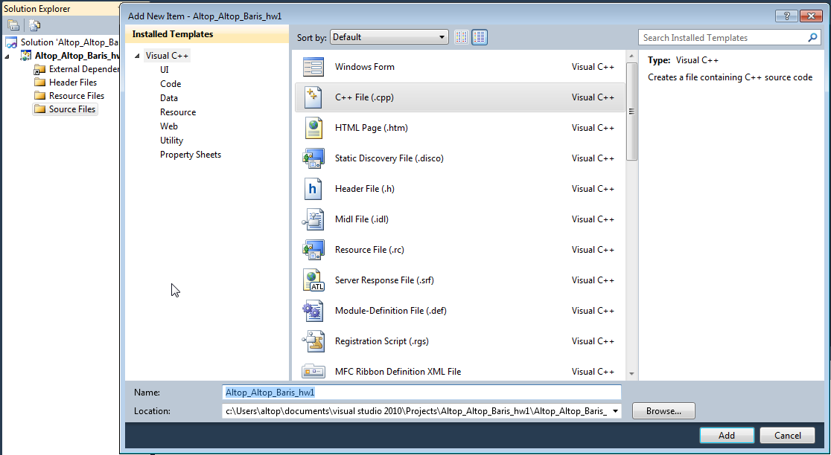

* Your SUCourse user name is actually your SUNet user name which is used for checking sabanciuniv e-mails. Do NOT use any spaces, non-ASCII and Turkish characters in the file name (**use only lowercase letters**). For example, if your SUCourse user name is cago, name is Çağlayan, and last name is Özbugsızkodyazaroğlu, then the file name must be:

**cago_ozbugsizkodyazaroglu_caglayan_hw1.cpp**

* Do not add any other character or phrase to the file name.
* Make sure that this file is the latest version of your homework program.

Submission:

* Submit via SUCourse ONLY! You will receive no credits if you submit by other means

(e-mail, paper, etc.).

1. Click on "Assignments" at CS201 SUCourse (not the CS201 web site).
2. Click Homework 1 in the assignment list.
3. Click on "Add Attachments" button.
4. Click on "Browse" button and select the cpp file that you generated.
5. Now, you have to see your file in the "Items to attach" list.
6. Click on "Continue" button.
7. Click on "Submit" button. We cannot see your homework if you do not perform this step even if you upload your file.

Resubmission:

* After submission, you will be able to take your homework back and resubmit. In order to resubmit, follow the following steps.

1. Click on "Assignments" at CS201 SUCourse.
2. Click Homework 1 in the assignments list.
3. Click on "Re-submit" button.
4. Click on "Add/remove Attachments" button
5. Remove the existing file by clicking on "remove" link. This step is very important. If you do not delete the old file, we receive both files and the old one may be graded.
6. Click on "Browse" button and select the new file that you want to resubmit.
7. Now, you have to see your new file in the "Items to attach" list.
8. Click on "Continue" button.
9. Click on "Submit" button. We cannot see your homework if you do not perform this step even if you upload your file.

**Successful submission is one of the requirements of the homework. If, for some reason, you cannot successfully submit your homework and we cannot grade it, your grade will be 0.**

***Good Luck!***

***Gülşen Demiröz***